**Lumos:7 reasons why my IoT startup failed**

By [Yash Kotak](https://yourstory.com/author/yash-kotak) June 24, 2015

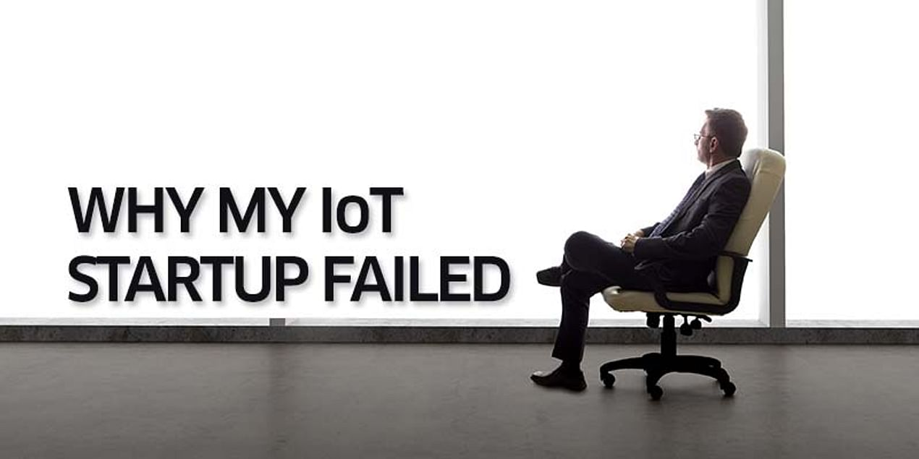

After five months of toiling 14-hour days, making a hardware IoT (Internet of Things) product from scratch and spending lakhs of rupees of investor money, it suddenly dawned to me and my two founders that our product won’t sell.

We had to do something about it or the startup was doomed. The month was December 2014.  
  
Being first-time entrepreneurs, we made tons of mistakes. I’ll mention the top seven mistakes we made that led to our failure. But first the story to give you some background!

**July 2014**

Our vision was to make super-smart internet connected switches that learn from user behaviour and personalize electronic appliances in a home to its owner. We named the product Lumos (Yes, I am a big Harry Potter Fan!)

We headed off to our alma mater, IIT-Gandhinagar, to get incubated after taking some pre-seed money from an angel investor. We converted a lab into our office space and the Lumos saga started!

We built like crazy. Being engineers, provided with an interesting problem to solve, we forgot everything else and just built. Our first prototype, which automated lights, was ready in 45 days.

The second prototype, which could automate lights, fans, ACs and water heaters was out in another month. Pretty fast for a 2-person team, building hardware and software at the same time!

**November 2014**

We got one more co-founder on board to help us out with machine learning. In mid-November, we started moving from the ugly-but-functional prototype stage to the beautiful product stage. In December, we were already in talks with investors to raise the next round of funding.

We were on track to have a hardware product on the market in less than one year. We were pleased with ourselves. The investors were pleased with us. Life was good.

**December 2014**

Until it was not. We had underestimated the work, time and funding that goes into making a market-ready hardware product. We had overestimated the demand and utility of our product.

“Hardware products sell at 4 to 5 times the component costs. How did we not know this?”

Our price estimates were wildly off the mark. And when all this realization came together, we were in a crisis.

**January 2015-April 2015**

We were forced into making major pivots.. We had to go back to the drawing board and think about what we should work on.

Not knowing what you will work on might just be second to running out of money, in the list of worst things that can happen in a startup.

We made bigger mistakes. We left IoT as a sector. One of our co-founders decided to call it a day and take up a job.

Now that you have some background, here are the top seven mistakes we made in Lumos and what we learnt from them.

**Mistake 1: We were neither experts nor target users of the product that we were building**

We had never used the existing home automation products in our homes. We were not veterans in the IoT sector. When you are inexperienced at something, you give yourself the famous Dunning-Kruger pass on your decisions.

Had we been users of existing smart switches, we would have known that the incremental value that our product was offering was quite low. Had we been experts in IoT, we would have known how to price hardware, and the difficulties in building it.

By avoiding this mistake, you can avoid a lot of other mistakes which happen as a result of this one.

**Learning:***Work on something where you are either an expert or a top user. If not, become an expert/top user.*

*Homejoy Founder Adora Cheung herself worked as a professional cleaner to understand the business.*

**Mistake 2: We did not do the due diligence on the idea before we started building the product**

We did not understand the market and competition well enough. We also did not figure out the persona of our customer, and whether the customer was looking for the value that we were providing.

It is always possible to validate or invalidate a lot of assumptions about the product, market and competition without building the full-fledged product.

One way we could have done it was by selling existing products to our potential customers.

**Learning:***I learnt this very useful method in an accelerator. Make a thorough list of hinge-breaking assumptions for your market, product and competition. Hinge breaking assumptions are those that can make or break your company.*

*Rank them according to probability of the assumption being wrong and subsequent risk to company. Start validating from the top while building as less as possible.*

**Mistake 3: We thought that we were smarter than everyone else**

I have seen this in dozens of entrepreneurs I met in the past year. I think it comes as a part of the entrepreneurial mindset; which makes cash-strapped entrepreneurs take on billion dollar companies and beat them at their game.

But it can also be a lethal trap; as it was in our case. We knew that companies like Belkin sold internet-connected switches at $50. How can they be so stupid? Don’t they understand that selling switches at a lower cost will give them better volumes? We will sell smarter switches at half the price. (Yeah, right!)

Nest’s machine learning algorithm is not perfect. But ours will be. You get the idea.

**Learning:***You will have to be smarter than your competitors to beat them. But you should be able to quantify why. You should have a logical answer to the famous YC question: “What do you understand about your business that other companies in it just don’t get?”*

*Answers like “Machine Learning” and “Better Design” usually don’t make the cut. You have to understand that your established competitors have more resources and more hiring power (Andrew Ng works with Google!). To beat them, you should be doing something fundamentally different.*

**Mistake 4: The ROI for our product did not make sense**

The incremental value that Lumos switches provided did not justify the cost that the target customer had to pay for it.

**Learning:***The value-pain equation for your product should make sense for your target customer. Unless value>pain, your product will not sell.*

*The product will not sell because it is cool; or because the market is projected to be worth $19 trillion in the next 5 years. It will only sell if customers get significant value out of the product.*

**Mistake 5: We let sunk cost bias affect our decisions about pivoting**

It was not that we were clueless about the problems in our product. We had doubts in our minds. In a startup, you almost always have doubts. But we had built so much. We were in love with our product. And we were not ready to ask the difficult questions.

Is it okay to be doubtful about your product? Is it okay to voice your doubts and bring the team morale down?

Or make your co-founders feel that you are not as committed to the idea and the vision as they are?

“It helps to be transparent about your doubts with co-founders in the long run.”

It would have saved us a couple of months and some money.

**Learning:***It is absolutely necessary for founders to be committed to the vision of the company. However, there are multiple ways to achieve a vision. Don’t fall in love with it one way. Accept the possibility that you might have to start things over from scratch.*

*Build a culture of transparency in your company. Encourage dissent among co-founders and deal with it objectively.*

**Mistake 6: We were trying to do everything for everybody**

We were making switches that could automate your lights, fans, ACs and water heaters. We would have tried to automate your TV, Fridge, Oven and Car as well had it been feasible to do so.

We were pitching power savings as well as luxury. This made the product and the pitch very complicated.

**Learning:***As a startup, you are constrained by your resources. So it is always better to identify and solve one problem very well instead of solving n problems in a so-so way.*

*Nest solved the heating problem. Dropcam and Canary solved the security problem. Try to be a drug for your customer instead of being a vitamin.*

**Mistake 7: We underestimated hardware**

Building a successful startup is hard. Building a hardware startup is 10 times harder.

Pebble, with all its Kickstarter success, is still in troubled waters.

Building a prototype is the easiest part of building a hardware startup. The real challenge comes in product design, production engineering, manufacturing, distribution and marketing/sales. And you need to have friends in China.

Also, hardware product validation and iteration cycles are much longer than software ones. Getting funding is relatively difficult; VCs ask for traction (~$1M on Kickstarter/Indiegogo, last I heard) because of the inherent risk in a hardware startup.

Managing cash flows is hard because you have to pay your vendors months before you get paid from your customers.([source](http://techcrunch.com/2014/04/06/the-lean-hardware-startup-investing-in-hardware-startups/))

Considering all this, we were not the right team to build a hardware company.

**Learning:***Understand what you are getting into if you are starting a hardware company and plan accordingly. Get experienced people on your team or get into a hardware accelerator like HAXLR8R.*

**Today**

Eventually, we ended up leaving hardware and IoT and decided to build something that solves a problem that we had experienced. Since Gandhinagar (where Lumos was located) does not have many startups, interacting and sharing experiences with other entrepreneurs was always a big problem for us. Also, we had to subscribe to a lot of blogs (crowded inbox) just to stay updated with top content on Entrepreneurship.

We decided to build FundaMine to solve this problem.

[FundaMine](http://www.fundamine.com/) is a community for professionals to discover what experts in their profession are reading and discussing. FundaMine has communities (mines) on Entrepreneurship, Product Management, Android Development and IoT. Do check it out and wish us luck!

**Startup Failure Post-Mortems 2015 First Update (8/15/2015)**

### **Lumos**

Title: [Five Reasons Why My IoT Startup Failed](https://medium.com/startup-lesson-learned/5-reasons-why-my-iot-startup-failed-19c5537e61e1)  
Title Link: <https://medium.com/startup-lesson-learned/5-reasons-why-my-iot-startup-failed-19c5537e61e1>

Product: [Lumos](https://www.cbinsights.com/company/lumos-design-technology)  
Product Link: <https://www.cbinsights.com/company/lumos-design-technology>

We had never used the existing home automation products in our homes. We were not experts in the IoT sector. When you have new at something, you give yourself the famous Dunning Kruger Pass on your decisions.

# Lumos Design Technology

ELECTRONICS | Electrical Product Distribution / Power Generation & Storage  
[iwearlumos.com](https://iwearlumos.com/)

## Founded Year

2012

## Stage

Dead | Dead

## Total Raised

$410K

## About Lumos Design Technology

Lumos has developed a technology that can turn backpacks or briefcases to a mobile charger. The solar backpack can house a laptop and other gadgets, and uses an innovative solar fabric to charge devices. The backpack has an in-built battery that can store the solar energy and can charge smartphones and other USB-based devices like MP3 players, Bluetooth headsets, etc. The backpack comes with a wide range of mobile phone connectors for different models.

## Lumos Design Technology Headquarter Location

CA Site No:1. JSS Institution Campus HAL 3rd Stage, Behind Hotel Leela Palace, Kodihalli

560 008,

India

+91-99801-61617

# **Lessons From My IoT Startup**

Yash Kotak Jun 8, 2015  
Title Link: <https://medium.com/startup-lesson-learned/5-reasons-why-my-iot-startup-failed-19c5537e61e1>  
After 5 months of toiling 14-hour days, making a hardware IoT product from scratch and spending thousands of dollars of Other People’s Money, I and my two co-founders woke up with a jolt. It suddenly dawned to us that our product would not sell. And unless we did something about it, the startup was doomed. This was December 2014.

Dreamy eyed noobs that we were, we made tons of mistakes. I hope this post helps you avoid some of those mistakes because as much as we glorify failure in the startup world, it does hurt. A lot.

Let me back-track a few months to give you some background. We started working on Lumos in July 2014. We were building smart internet connected switches that learn from user behavior and automate all the electronic appliances in a home. We took some pre-seed investment from an angel investor and headed off to our alma mater IIT Gandhinagar to get incubated.

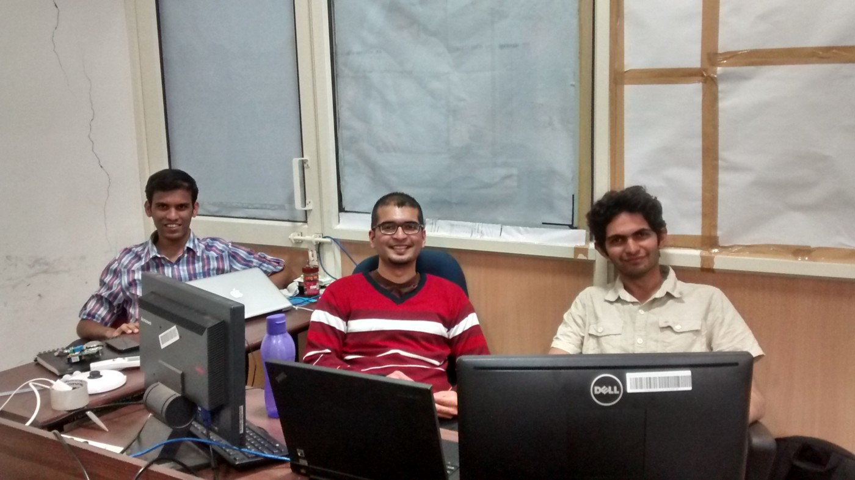

The Lumos Team at work!

We built like crazy. That’s the thing about us engineers; if you give us something interesting to build, we will forget everything else and just build. Our first prototype, which automated lights, was ready in 45 days. The second prototype, which could automate lights, fans, ACs and water heaters was out in another month. This is a really impressive speed for a hardware product.

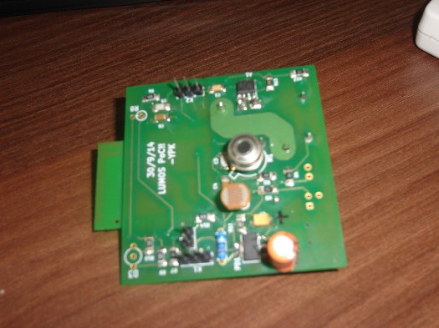

The first PCB built by Lumos!

In mid-November, we got a product designer on board to design the final product. In December, we were already in talks with investors to raise the next round of funding. We were on track to have a market-ready hardware product in less than one year. We were pleased with ourselves. The investors were pleased with us. Life was a bed of roses.

Until it was not. We had underestimated the work that goes into making a market-ready hardware product. We had overestimated the demand and utility of our product. We were wildly wrong about the price at which we thought our product would sell. And when all this realization came together, shit got real.

We were forced into a deathly spiral of pivots that almost killed the company. We made bigger mistakes. We left IoT as a sector. We lost a cofounder on the way. The pivots are a long story. I’ll save it for another day.

Now that you have some background, here are the top 5 mistakes we made in Lumos and what we learnt from them.

**Mistake 1: We were neither experts nor target users of the product that we were building.**

We had never used the existing home automation products in our homes. We were not experts in the IoT sector. When you have new at something, you give yourself the famous Dunning Kruger Pass on your decisions.

“The Dunning–Kruger effect is a cognitive bias wherein unskilled individuals suffer from illusory superiority, mistakenly assessing their ability to be much higher than is accurate.”

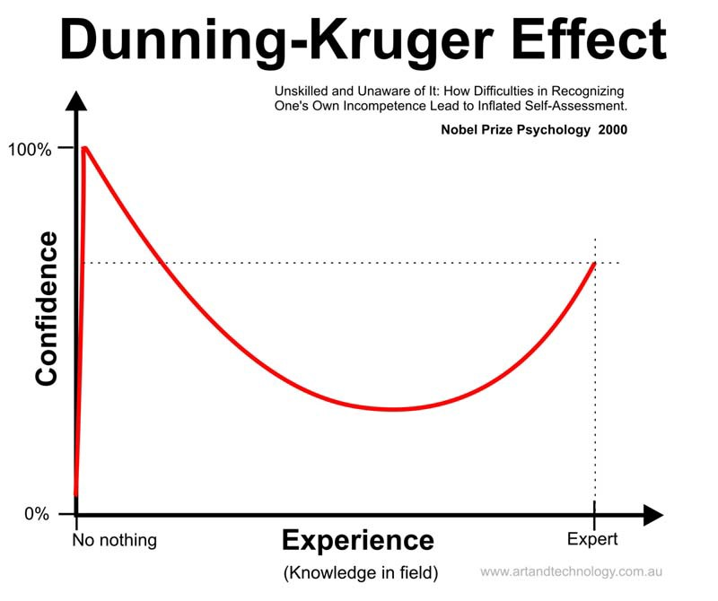

And we did give ourselves the Dunning Kruger pass. Had we been users of existing smart switches, we would have known that the incremental value that our product was offering was quite low. Had we been experts in IoT, we would have known how to price hardware and the difficulties in building it.

By avoiding this mistake, you can avoid a lot of other mistakes which happen as a result of this one.

**Learning:***Work on something where you are either an expert or a top user. If not, become an expert/top user. Homejoy founder Adora Cheung herself worked as a professional cleaner to understand the business.*

**Mistake 2: We did not do the due diligence on the idea before we started building the product.**

We did not understand the market and competition well enough. We also did not figure out the persona of our customer. And whether that customer was looking for the value that we were providing. We did not question whether we would be able to provide that value in that first place.(Machine Learning cannot read the human mind. Not yet!).

It is always possible to validate/disvalidate a lot of assumptions about the product, market and competition without building the full-fledged product. One way we could have done it was by selling existing products to our potential customers.

**Learning:***I learnt this very useful method in an accelerator. Make a thorough list of hinge-breaking assumptions for your market, product and competition. Hinge breaking assumptions are those that can make or break your company. Rank them according to probability of the assumption being wrong and subsequent risk to company. Start validating from the top while building as less as possible.*

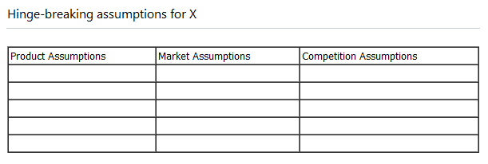

**Mistake 3: We let sunk cost bias affect our decisions about pivoting.**

It was not that we were clueless about the problems in our product. We had doubts in our minds. In a startup, you almost always have doubts. But we had built so much. We were in love with our product. And we were not ready to ask the difficult questions.

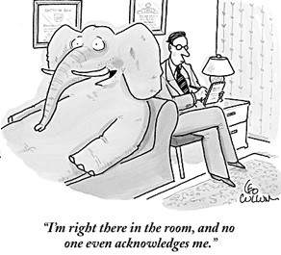

Is it okay to be doubtful about your product? Is it okay to voice your doubts and bring the team morale down? Or make your cofounders feel that you are not as committed to the idea and the vision as they are?

It helps to be transparent about your apprehensions with cofounders in the long run. It would have saved us a couple of months and some money.

**Learning:***It is absolutely necessary for founders to be committed to the vision of the company. However, there are multiple ways to achieve a vision. Don’t fall in love with one way. Accept the possibility that you might have to start things over from scratch.*

*Build a culture of transparency in your company. Encourage dissent among cofounders and deal with it objectively.*

**Mistake 4: We were trying to do everything for everybody.**

We were making switches that could automate your lights, fans, ACs and water heaters. We would have tried to automate your TV, Fridge, Oven and Car as well had it been feasible to do so. We were pitching power savings as well as luxury. This made the product and the pitch very complicated.

**Learning:***As a startup, you are constrained in resources. So it is always better to identify and solve one problem very well instead of solving n problems in a so-so way. Nest solved the heating problem. Dropcam and Canary solved the security problem. Try to be a drug for your customer instead of being a vitamin.*

**Mistake 5: We underestimated hardware.**

Building a successful startup is hard. Building a hardware startup is 10 times harder. Pebble, with all the Kickstarter success, is still in troubled waters.

Building a prototype is the easiest part of building a hardware startup. The real challenge comes in product design, production engineering, manufacturing, distribution and marketing/sales. And you need to have friends in China.

Also, hardware product validation and iteration cycles are much longer than software ones. Getting funding is relatively difficult; VCs ask for traction(~$1M on Kickstarter/Indiegogo last I heard)because of the inherent risk in a hardware startup. Managing cash flows is hard because you have to pay your vendors months before you get paid from your customers.

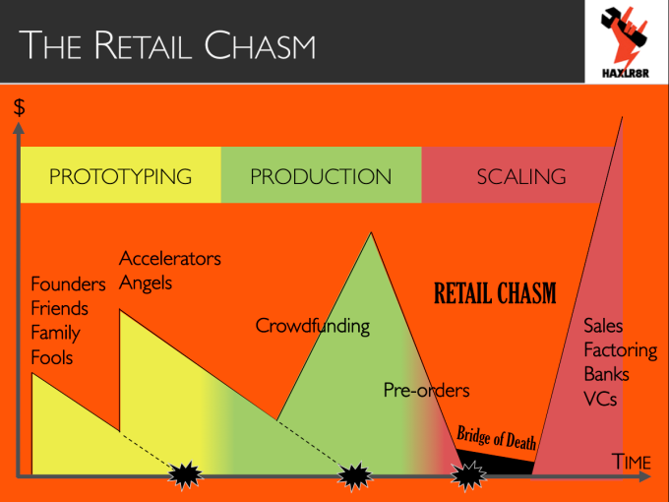

Source: <http://techcrunch.com/2014/04/06/the-lean-hardware-startup-investing-in-hardware-startups/>

We were not the right team to build a hardware company.

**Learning:***Understand what you are getting into if you are starting a hardware company and plan accordingly. Get experienced people on your team or get into a hardware accelerator like HAXLR8R.*

So these were our top 5 mistakes that I can see in retrospect. Eventually, we ended up leaving hardware and IoT and decided to build something that solves a problem that we had experienced.

Since Gandhinagar(where Lumos was located) does not have many startups, interacting and sharing experiences with other entrepreneurs was always a big problem for us. Also, we had to subscribe to a lot of blogs (crowded inbox) just to stay updated with top content on Entrepreneurship. We decided to build FundaMine to solve this problem.

**[FundaMine](http://www.fundamine.com/) is a community for professionals to stay updated and interact with others in their profession.**

Currently, FundaMine has communities(mines) on Entrepreneurship, Product Management, Android Dev and IoT. Do check it out!

Drop me a line at [yashpkotak@gmail.com](mailto:yashpkotak@gmail.com) if you have any comments or want to discuss anything in detail. If you are in Bangalore, we can also catch up for a cup of coffee!

If you liked this post, please recommend it or share it with fellow entrepreneurs!